# ODE Modeling Exercises

## Exercise 3: ODE Modeling. Single reaction model - Solutions

**ODE Modeling basics:**

1. What are the two main assumptions made in kinetic modeling of metabolic reactions with Ordinary Differential Equations (ODEs)?

Answer: 1. The number of molecules in large

2. The system is well-mixed (no spatial heterogeneities)

(In the lecture slides, it can be found in Stelling-1, p.22 and Sauer-2, p.22)

1. Write formulas for two elementary reactions (production and degradation) using ODEs.

Answer:

 

 

**Learning to build ODE models through a simple substrate-product reaction system.**

Consider the following simple enzymatic reaction mechanism

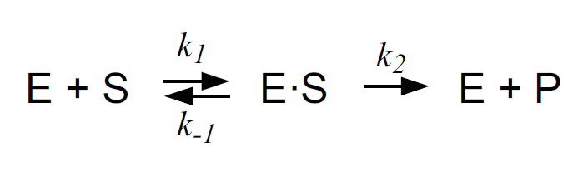

3) Enzyme Kinetics: Mass Action Law vs. Approximation (Michaelis – Menten Law). The above described artificial system includes four species / state variables (E, S, ES, P).

1. What are the two assumptions and two simplifications that were made to derive an analytical solution for the Michaelis Menten approximation?

Answer: (In the lecture, Stelling-1 pp.23-26)

* *No feedback by the product P: [P] depends only on [ES]*
* *Enzyme is conserved – total amount is constant: [E]total = [E] + [ES]*
* *System is in Quasi steady state: The amount of ES is constant: $\frac{dES}{dt}≈0$*
* *Excess of substrate S*

In the script “EnzymeKineticsMassAction.m”, this system is already defined assuming mass action kinetics for the three reactions. Run this script to simulate the change in concentrations of the four species over time.

* 1. In the provided MATLAB code, find the values of the reaction rate constants k1, k-1, k2.  
     Answer: *k1: 0.1; k-1: 0.01; k2:1.99*
  2. The simulated results are stored in the struct “simData” which is generated when you simulate the ODE model. Plot the results for all species (E, S, ES, P).  
     Answer: insert the plot here

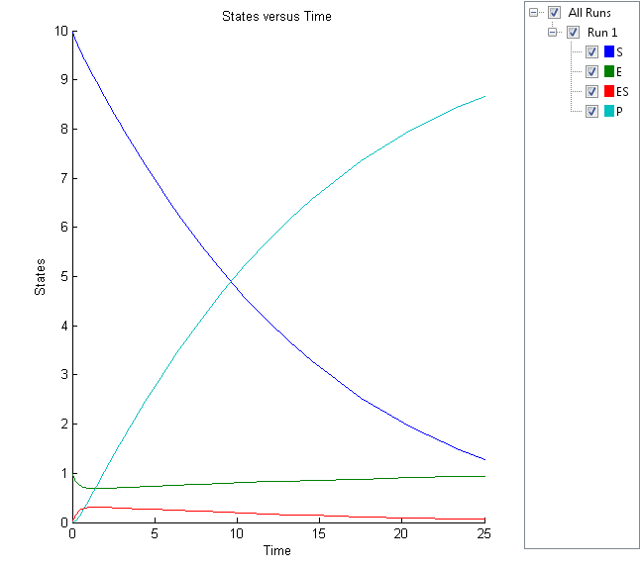

* 1. In the plot, identify (approximately) the pre-steady state regime and the quasi steady state regimes. Does the total enzyme in the system change?   
     Answer: pre-steady regime: from time 0 to ~2 sec

quasi Steady state: from time ~2 to ~10 sec

No, the total enzyme amount does not change, only the share in ES complex vs free E changes over time.

1. Using the Michaelis Menten definition, calculate the Km value of the enzyme E.   
   *Hint: Use the k1, k-1, k2 values you identified.*

Answer: $K_{m}=\frac{k_{-1}+k_{2}}{k_{1}}=20$

1. In the script “EnzymeKineticsMM.m”, the reaction from S to P is defined using the Michaelis-Menten kinetics. In a for loop, the initial velocity (v0) of this reaction is calculated for different initial concentrations of the substrate S (from 1 to 600). Run this script to simulate the system and create the vector of v0.
2. Plot reaction rates (v0) vs. substrate concentrations ([S]). From the plot, estimate the Vmax and Km values.

Answer:

C:\Users\Christian\Dropbox\System Bio\Woche 2\untitled.tif

Vmax =2, Km = 20 (concentration, at which v = ½ * vmax).

1. Increase the “InitialAmount” of the species “E” by 10 units. Run the script, plot the v0 vs. S and estimate again the Vmax and the Km values of the system. What do you observe?

Answer:

* Vmax changes to 22
* KM remains constant (still 20)

**Pen and Paper exercise: Michaelis Menten kinetics with competitive inhibition**

Consider the following enzymatic reaction mechanism:

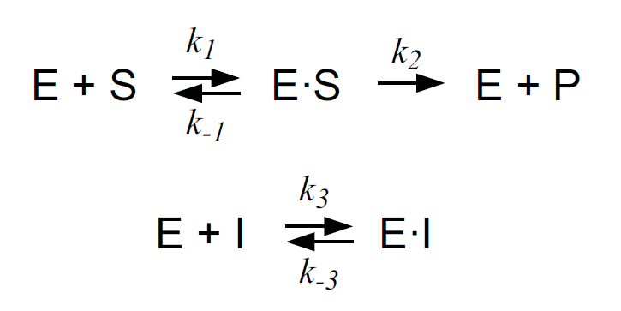

4) Write the Balance Equations for the species’ concentrations of the above reactions under the assumption of mass-action kinetics.

5) Derive the reaction rate expression ($v$) for competitive inhibition, given the following assumptions:

* Quasi Steady State assumption for intermediate complexes ES and EI: $\frac{d[ES]}{dt}=0,\frac{d[EI]}{dt}=0$
* Conservation of Enzyme $(E$) species: $E_{T}=E+ES+EI$

$\frac{d[P]}{dt}=reaction rate=v$

*Hint*: The final formula of the rate law should look like: $\frac{d[P]}{dt}=v=\frac{V_{max}*[S]}{\left[S\right]+ K_{m}(1+\frac{[I]}{K_{I}})}, \left[S\right]≅[S_{0}]$  
Answer: See PenAndPaperExercise.pdf (both MM and MM with comp. inhibition derivations) and below

**Simplification 1: Quasi Steady State Assumption (ES and EI)**

$$\frac{d\left[ES\right]}{dt}=0 \overset{⇔}{ } k_{1}\left[E\right]\left[S\right]-{(k}_{-1}+k_{2})[ES]= 0 \overset{⇔}{ } k_{1}\left[E\right]\left[S\right]={(k}_{-1}+k_{2})[ES]\overset{⇔}{ }$$

$$\left[E\right]=\frac{{(k}_{-1}+k_{2})[ES] }{k_{1}\left[S\right]} \overset{⇔}{We know: k_{m}=\frac{{(k}_{-1}+k_{2})}{k_{1}}}$$

$\left[E\right]=k_{m}\frac{\left[ES\right]}{\left[S\right]}$**, Eq. 1**

$$\frac{d\left[EI\right]}{dt}=0 \overset{⇔}{ } k_{3}\left[E\right]\left[I\right]-k_{-3}\left[EI\right]=0 \overset{⇔}{ } k_{-3}\left[EI\right]=k_{3}\left[E\right]\left[I\right] \overset{⇔}{ } \left[EI\right]=\frac{k_{3}\left[E\right]\left[I\right]}{k_{-3}}$$

$$\overset{⇔}{ } \left[EI\right]=\frac{\left[E\right]\left[I\right]}{\frac{k_{-3}}{k_{3}}} \overset{⇔}{K_{I}= \frac{k_{-3}}{k_{3}}} \left[EI\right]= \frac{\left[E\right]\left[I\right]}{K_{I}} \underset{⇒}{Eq. 1}$$

$$\left[EI\right]=\frac{k_{m}\left[ES\right]\left[I\right]}{K_{I}\left[S\right]} ,Eq. 2$$

**Simplification 2: Conservation of E (${\left[E\right]}^{T}$** is referring to the Total Enzyme)

$${\left[E\right]}^{T}= \left[E\right]+\left[ES\right]+\left[EI\right] \underset{⇒}{From Eq. 1 and Eq.2}$$

$${\left[E\right]}^{T}= k_{m}\frac{\left[ES\right]}{\left[S\right]}+ \left[ES\right]+ \frac{k_{m}\left[ES\right]\left[I\right]}{K_{I}\left[S\right]} \overset{⇔}{ } {\left[E\right]}^{T}= \left(\frac{k_{m}}{\left[S\right]}+1+\frac{k_{m}\left[I\right]}{K_{I}\left[S\right]}\right)\left[ES\right] \overset{⇔}{ }$$

$$\left[ES\right]= \frac{{\left[E\right]}^{T}}{\left(\frac{k_{m}}{\left[S\right]}+1+\frac{k_{m}\left[I\right]}{K_{I}\left[S\right]}\right)}= \frac{{\left[E\right]}^{T}\left[S\right]}{k_{m}+\left[S\right]+\frac{k_{m}\left[I\right]}{K_{I}}} \overset{⇔}{ }$$

$$\left[ES\right]=\frac{{\left[E\right]}^{T}\left[S\right]}{\left[S\right]+k_{m}(1+\frac{\left[I\right]}{K_{I}})} , Eq.3$$

**Given the above, we have:**

$$v= \frac{d\left[P\right]}{dt}=k_{2}\left[ES\right] \underset{⇔}{Eq. 3} \frac{d\left[P\right]}{dt}= \frac{k_{2}{\left[E\right]}^{T}\left[S\right]}{\left[S\right]+k_{m}\left(1+\frac{\left[I\right]}{K_{I}}\right)} \overset{⇔}{ Vmax= k_{2}{\left[E\right]}^{T}}$$

$$\frac{d\left[P\right]}{dt}=v=\frac{V_{max}\left[S\right]}{\left[S\right]+k_{m}\left(1+\frac{\left[I\right]}{K_{I}}\right)}$$

**Understanding the effect of competitive inhibition in reaction rates with an ODE model**

6) Implement and simulate an ODE model describing the above reaction (with competitive inhibition). Name you script “EnzymeKineticsMMwCompInhib.m”. Make use of the MM rate law for competitive inhibition that you derived. Use the same values for the parameters Kcat, Km as in the simple MM model. Do the same for the InitialAmount values of species S and E (use **1 unit** as initial value for species E).

*KI = 6 units, InitialAmount of Inhibitor (I) = 10* *units*

1. Does Vmax change, and if yes what is the new value?

Answer: Vmax remains the same (Vmax = 2)

1. Does the apparent Km change and if yes what is the new value?

Answer: Km apparent changes, Km*app* ~= 53